STUDY SHEET
IDIOM | MEANING | EXAMPLE
- nosy | too interested in what other people are doing and wanting to discover too much about them | There is this nosy lady that works in my office, and she is always looking at my computer!
- winning the future | the phrase President Obama is using to describe his new vision for more targeted spending in key areas like education, infrastructure and clean energy | Obama to Businesses: Winning the Future is About What You Can Do to Help America Succeed.
- heat up | a situation in which people are arguing or competing with each other and it becomes more serious or more violent | - United Nations forces were called in as the conflict heated up.  - As growth in the business slows, competition is heating up.
- figure out | to understand something or someone, or to find the answer to something by thinking carefully | - I can't figure out why he did it.  - I've never been able to figure Sue out.
- homesick | unhappy because of being away from home for a long period | As I read my mother's letter, I began to feel more and more homesick.
- after hours | occurring after closing time | I often do some of my work after hours.
- The grass is always greener (on the other side of the fence). | other people always seem to be in a better situation than you, although they may not be | - I sometimes think I'd be happier teaching in Spain. Oh well, the grass is always greener on the other side!  - Don't compare your talents with others. The grass is always greener on the other side of the fence. Just do your best.
- pass away | to die | - She passed away peacefully in her sleep.  - I've lived on my own since my husband passed away five years ago.
- come clean | to tell the truth, often about something bad that you have been trying to keep a secret | - I felt it was time to come clean and tell her what the doctor had told me.  - It's time for the Governor to come clean about the proposed tax increase.

IDIOM | MEANING |  | EXAMPLE
- make up one's mind | - to decide what to choose |  | - I can't make up my mind whether to have the salmon or the chicken.
 | - to become very certain that you want to do something |  | - At a very early age she made up her mind to become an actress.  - My mind's made up. I'm handing in my resignation tomorrow.
- bite-sized | - small enough to be put whole into your mouth |  | Cut the chicken into bite-sized pieces.
 | - small enough to be read or dealt with easily |  | The guides are produced in bite-sized sections.
- cost an arm and a leg | to be very expensive |  | These opera tickets cost us an arm and a leg!
Origin:  In George Washington's days, there were no cameras. One's image was either sculpted or painted. Some paintings of George Washington showed him standing behind a desk with one arm behind his back while others showed both legs and both arms.  Prices charged by painters were not based on how many people were to be painted, but by how many limbs were to be painted. Arms and legs are limbs, therefore painting them would cost the buyer more. Hence the expression, "Okay, but it'll cost you an arm and a leg." |  | 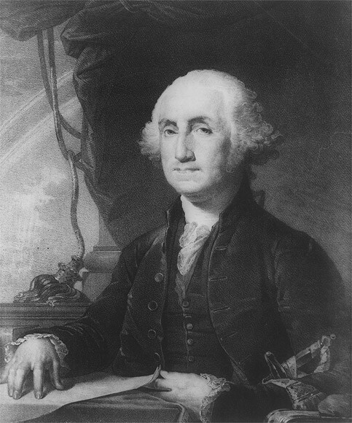

FITB
- As I read my mother's letter, I began to feel more and more ____________________.  - I can't ____________________ why he did it.  - I can't ________________________________________ whether to have the salmon or the chicken.  - I often do some of my own work ____________________.  - I sometimes think I'd be happier teaching in Spain. Oh well, ________________________________________ on the other side!  - It's time for the Governor to ____________________ about the proposed tax increase.  - I've lived on my own since my husband ____________________ five years ago.  - Obama to Businesses: ____________________ the future is About What You Can Do to Help America Succeed.  - The guides are produced in ____________________ sections.  - There is this ____________________ lady that works in my office, and she is always looking at my computer!  - These opera tickets cost us ______________________________!  - United Nations forces were called in as the conflict ___________ _________. | - after hours  - an arm and a leg  - bite-sized  - come clean  - figure out  - heated up  - homesick  - make up one's mind  - nosy  - passed away  - the grass is always greener  - Winning

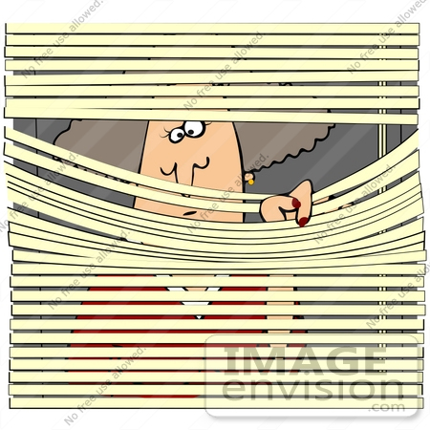

Matching
- after hours  - bite-sized  - come clean  - cost an arm and a leg  - figure out  - heat up  - homesick  - make up one's mind  - nosy  - pass away  - The grass is always greener (on the other side of the fence).  - winning the future | - a situation in which people are arguing or competing with each other and it becomes more serious or more violent  - occurring after closing time  - other people always seem to be in a better situation than you, although they may not be  - the phrase President Obama is using to describe his new vision for more targeted spending in key areas like education, infrastructure and clean energy  - to be very expensive  - 1. to decide what to choose 2. to become very certain that you want to do something  - to die  - to tell the truth, often about something bad that you have been trying to keep a secret  - to understand something or someone, or to find the answer to something by thinking carefully  - too interested in what other people are doing and wanting to discover too much about them  - unhappy because of being away from home for a long period  - 1. small enough to be put whole into your mouth 2. small enough to be read or dealt with easily



