STUDY SHEET
IDIOM | MEANING | EXAMPLE
- come down with something | to become ill, usually with a disease that is not very serious | I think I'm coming down with a cold - I've been coughing all day.
- hold off somebody or something | to prevent someone from attacking you, or to prevent something from happening | A small group of guerrilla forces managed to hold off the government army.
- a sitting duck | something or someone that is easy to attack or criticize | - The elderly are often sitting ducks for shady financial deals.  - The tourists were sitting ducks for local thieves.
- the apple of somebody's eye | the person who someone loves most and is very proud of | His youngest son was the apple of his eye.
- pick somebody's brains | to ask for information or advice from someone who knows more about a subject than you do | I'd love to pick your brains about computers - you seem to be the expert around here.
- nice ride | unique car; fun to drive vehicle | That Saturn Sky or Lotus are a nice ride.
- A bird in the hand (is worth two in the bush). | something that you say which means it is better to keep what you have than to risk losing it by trying to get something better | If I were you I'd accept the money they're offering. After all, a bird in the hand...
- play with fire | to be involved in an activity that could be dangerous | We're playing with fire if we continue with genetic modification of our food.
- Beat it! | a rude way of telling someone to go away | You better run, you better do what you can. Don't wanna see no blood, don't be a macho man. You wanna be tough, better do what you can, so beat it.
- a white elephant | something that has cost a lot of money but has no useful purpose | The town's new leisure center, recently completed at a cost of ten million pounds, seems likely to prove a white elephant.
- tie the knot | to get married | - When are you two going to tie the knot?  - She's planning to tie the knot with her German boyfriend next June.
- up-to-date | modern, recent, or containing the latest information | Great trouble is taken to keep our database up-to-date.
- fight like cats and dogs | to argue violently all the time | We get on very well as adults but as kids we fought like cats and dogs.
- kick the bucket | to die | Didn't you hear? He kicked the bucket. Had a heart attack, I think.

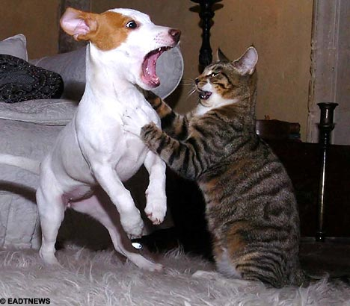

FITB
- A small group of guerrilla forces managed to ____________ ________ the government army.  - Didn't you hear? He ____________________ the bucket. Had a heart attack, I think.  - Great trouble is taken to keep our database _______________.  - His youngest son was ____________________ his eye.  - I think I'm ____________________ with a cold - I've been coughing all day.  - I'd love to pick your ____________________ about computers - you seem to be the expert around here.  - If I were you I'd accept the money they're offering. After all, a bird ____________________...  - She's planning to tie the ____________________ with her German boyfriend next June.  - That Saturn Sky or Lotus are a nice ____________________.  - The tourists were ____________________ for local thieves.  - The town's new leisure center, recently completed at a cost of ten million pounds, seems likely to prove a _______________ elephant.  - We get on very well as adults but as kids we fought like cats ____________________.  - We're playing ____________________ if we continue with genetic modification of our food.  - You better run, you better do what you can. Don't wanna see no blood, don't be a macho man. You wanna be tough, better do what you can, so ____________________. | - and dogs  - beat it  - brains  - coming down  - hold off  - in the hand  - kicked  - knot  - ride  - sitting ducks  - the apple of  - up-to-date  - white  - with fire

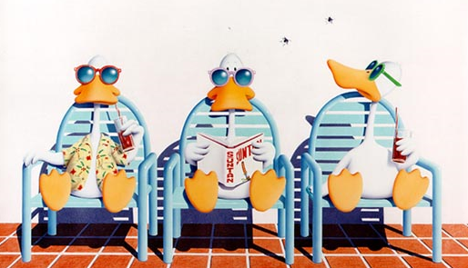

Matching
- _____ A bird in the hand (is worth two in the bush).  - _____ a sitting duck  - _____ a white elephant  - _____ Beat it!  - _____ come down with something  - _____ fight like cats and dogs  - _____ hold off somebody or something  - _____ kick the bucket  - _____ nice ride  - _____ pick somebody's brains  - _____ play with fire  - _____ the apple of somebody's eye  - _____ tie the knot  - _____ up-to-date | - a rude way of telling someone to go away  - modern, recent, or containing the latest information  - something or someone that is easy to attack or criticize  - something that has cost a lot of money but has no useful purpose  - something that you say which means it is better to keep what you have than to risk losing it by trying to get something better  - the person who someone loves most and is very proud of  - to argue violently all the time  - to ask for information or advice from someone who knows more about a subject than you do  - to be involved in an activity that could be dangerous  - to become ill, usually with a disease that is not very serious  - to die  - to get married  - to prevent someone from attacking you, or to prevent something from happening  - unique car; fun to drive vehicle


